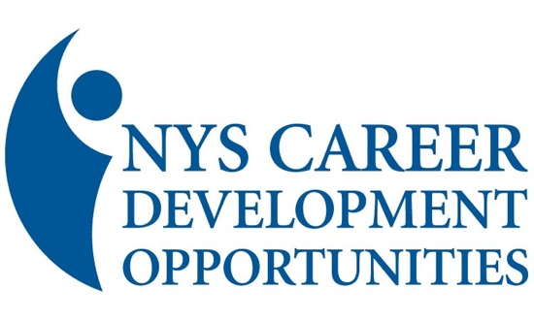

HERStory Project Submission

For Publication in the Spring 2026 NIKE Magazine
Due 5/1/26

Submitted by:

Address:

City: State: Zip:

Best Contact Phone: Email:

Honoree Name:

Information regarding the Honoree (not to exceed 100 words):


Submitting a picture? YES NO

A picture is optional. If submitting, please email to nyscdo@gmail.com.

Minimum donation $25.00 towards the Youth Leadership Fundraiser

HERStory donation: $ __25.00____
Additional Donation: $___________
Total Enclosed $___________

Please make checks payable to “NYS Career Development Opportunities Inc” and put “HERStory” in the memo field.

Mail this form with your check to: Sara Ayala, (CDO Treasurer) 32 Woodbury Road, New Hartford, NY 13413

